GTZAN Genre Classification – Project Report

Introduction
Music genre classification is a fundamental task in music information retrieval (MIR). The goal is to automatically categorize music tracks into predefined genres based on audio features. This project uses the GTZAN dataset, a benchmark dataset containing 10 genres (blues, classical, country, disco, hiphop, jazz, metal, pop, reggae, rock).
We explore two main approaches:
- Tabular features-based learning using MFCCs and other handcrafted features (RandomForest, MLP).
- Image-based deep learning using spectrograms with Convolutional Neural Networks (CNN) and Transfer Learning (MobileNetV2).

Dataset
- GTZAN Music Genre Dataset: 1000 audio tracks, each 30 seconds long, across 10 balanced genres.
- Files are provided in .wav or .au format, grouped by genre.
- Supplementary CSV files (features_30_sec.csv, features_3_sec.csv) contain pre-extracted features such as tempo, spectral centroid, MFCC statistics, etc.
Dataset composition:
- 10 genres, 100 tracks per genre.
- features_3_sec.csv → segmented into 3-second slices, increasing the sample size to nearly 10,000.
- Spectrograms → generated from raw audio to serve as images for CNN and transfer learning.

Preprocessing
- Tabular data (CSV)
  - Removed non-numeric columns (filename, label).
  - Applied Label Encoding for genre labels.
  - Standardized features using StandardScaler.
- Raw audio (if CSV not available)
  - Extracted MFCC mean and variance per file.
- Spectrogram images
  - Generated mel-spectrograms using librosa.
  - Normalized spectrograms and resized to 128×128.
  - Expanded dimensions for CNN input (channel-last format).
  - For MobileNetV2, converted grayscale spectrograms into 3-channel RGB images.

Models

Tabular Models
- RandomForest Classifier: Ensemble method using decision trees.
- MLP (Multilayer Perceptron): Fully connected neural network with 2 hidden layers, ReLU activation, and dropout regularization.

Image Models
- CNN from scratch: 3 convolutional layers + pooling, followed by dense layers.
- Transfer Learning (MobileNetV2): Pre-trained on ImageNet, fine-tuned with a custom classification head for GTZAN.

Evaluation Metric
Models are evaluated using:
- Accuracy – overall correct predictions.
- Precision, Recall, F1-score – per-genre evaluation.
- Confusion Matrix – to visualize misclassifications across genres.

Results

RandomForest (Tabular)
- Accuracy: 87%
- Strong performance across most genres (classical, hiphop, metal).
- Struggled slightly with rock vs pop confusion.
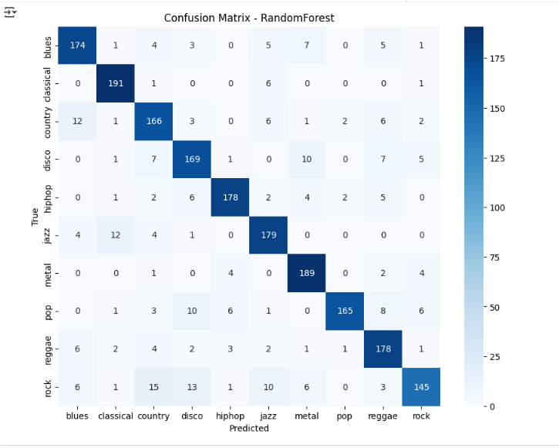

MLP (Tabular)
- Accuracy: 87%
- Comparable to RandomForest, with better generalization on blues and jazz.
- Performance dropped slightly on country and rock.
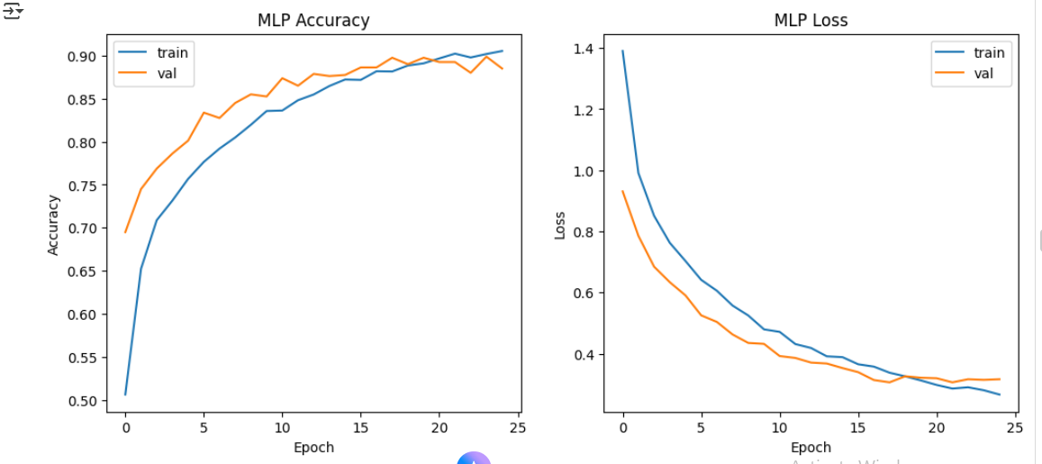

CNN (Spectrograms)
- Accuracy: 38%
- Performed poorly compared to tabular models.
- Likely due to small training set per genre (only 100 samples) and limited CNN depth.
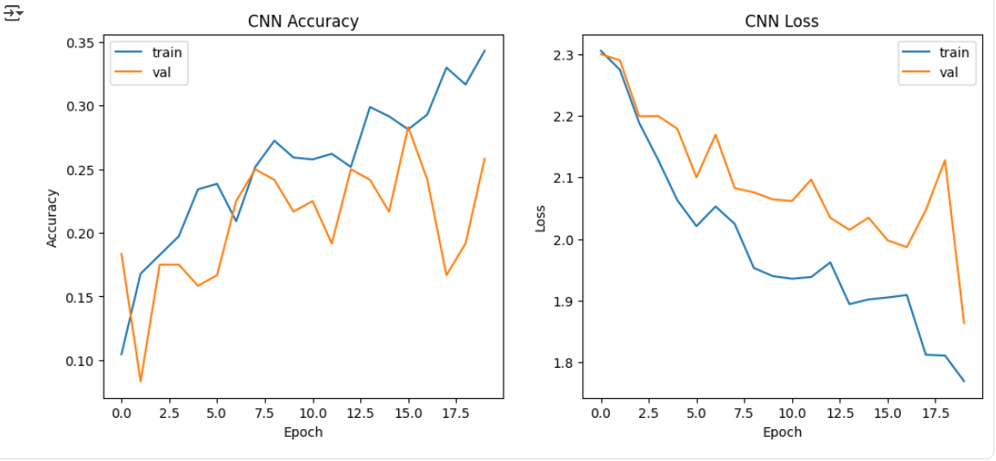

Transfer Learning (MobileNetV2)
- Accuracy: 26%
- Failed to generalize well on this dataset.
- Overfitting likely due to small dataset size and mismatch between spectrogram images and natural images MobileNetV2 was pretrained on.
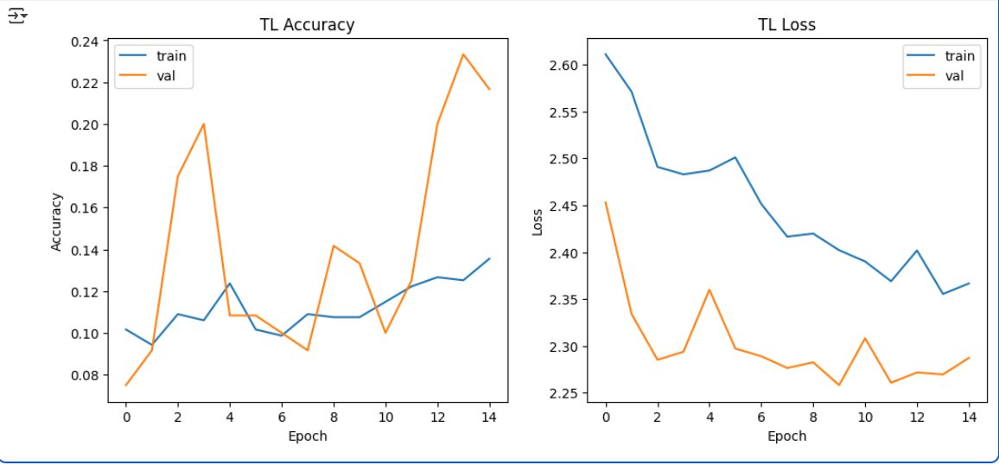

Conclusion
- Tabular feature-based models (RandomForest, MLP) significantly outperform image-based models for GTZAN when training on limited samples.
- RandomForest and MLP both reached ~87% accuracy, which is competitive with many published results.
- CNN and MobileNetV2 performed poorly, showing that spectrogram image-based approaches require larger datasets or heavy augmentation to succeed.

Future Works
- Data Augmentation: Apply pitch shifting, time stretching, noise injection, and mix-up to enlarge dataset.
- More advanced architectures: Try ResNet, EfficientNet, or 1D-CNN + LSTM hybrids directly on MFCC sequences.
- Segment-level modeling: Aggregate predictions from 3-second chunks instead of entire 30-second tracks.
- Transfer learning with music-specific models (e.g., VGGish, OpenL3, or YAMNet pretrained on AudioSet).
- Hyperparameter optimization: Tune dropout, learning rate, and CNN filter sizes.
- Cross-dataset validation: Test generalization on other music datasets beyond GTZAN.

